Visual Simulation of Clouds

The visual simulation of clouds is a difficult problem to deal with computers due to its surface, boundary and opacity change every time and require very complex mathematical models to produce a single simulation. For that reason there exists different method of developing acceptable representation efficiently.

To develop comprehensive clouds we have to note that their formation could be in vertical or horizontal way and use 3 basic components:

1. Sky plane: to model 2D cloud viewed from a distance.



1. Ellipsoids: to model 3D gross clouds.

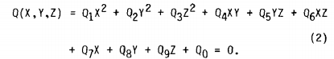

1. Mathematical texturing function: for modelling clouds details, changing intensity and translucence. We do this using a “poor man’s Fourier serie”.

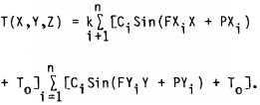

A 2D cloud model can be defined as a single plain in the sky placed at any altitude (A), with any spectral content (Ci,FXi,FYi,T0). This kind of modelling is limited because his lack of vertical depth and is the reason that is only used as a background of 3D scenes.

The 3D cloud model start out with the ellipsoid as the basic form to build 3D structures of clouds, it can be used to define the whole volume with only 9 parameters (3 sizes, 3 positions, 3 orientation), using the texturing function to simulate the secondary topographical details. The texture is defined by specifying the frequencies and amplitudes of the function sine waves to produce the desired cloud density. For those clouds that are not very similar to a ellipsoid, the model can link ellipsoids to create more complex shapes.

When we want to create a horizontal cloud formation we create a cluster of ellipsoids specifying size and orientation parameters, we also define a horizontal elliptical boundary for the cluster and the altitude of the layer. All the ellipsoids in the cluster are assigned a common colour and texture. For more complex scenes we can create a macrocluster that define subclusters that create the ellipses.

If we want to create vertical clouds formation we can vary the size of the ellipsoid in a controlled manner, pushing the ellipsoids upward to create the sensation updrafts…